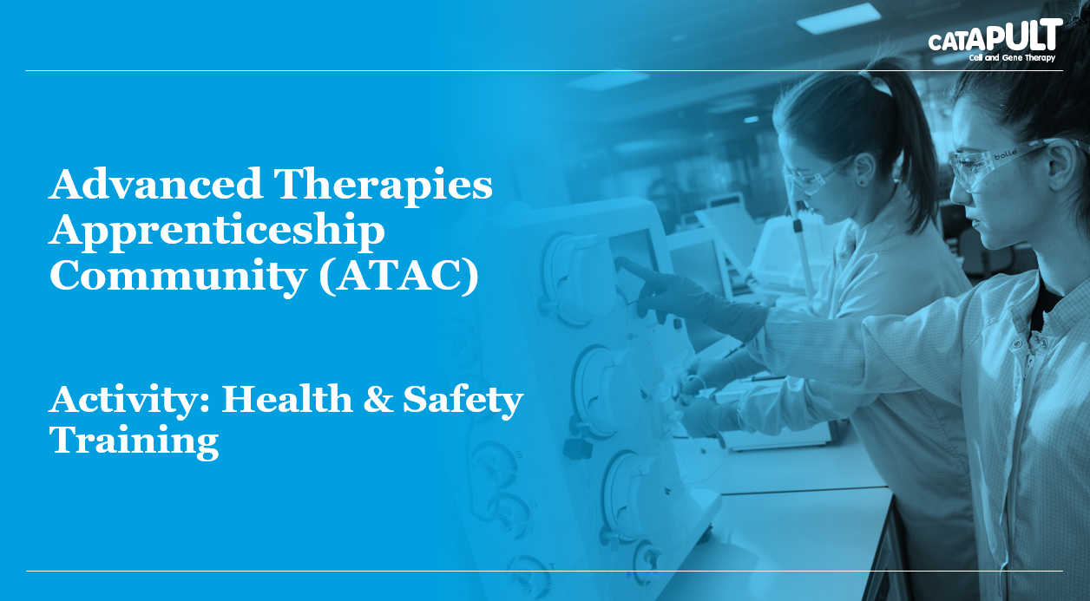

Understanding the Health and Safety requirements of our industry is a vital part of operating within a highly regulated environment. From using protective personal equipment, assessing risks associated with your own work to dealing with incidents occupational health and safety knowledge is both indispensable to a healthy and safe working environment and a fundamental element of apprenticeships across the science industry. This training will provide an externally recognised health and safety qualification that increases your knowledge and provides vital evidence for your apprenticeship.
Target Audience: Apprentices with no prior health and safety training on apprenticeship standards: Technician Scientist and Science Manufacturing Technician.
Duration: 1 day classroom based training and multiple choice examination assessment
Learning Outcomes:
- Understand your role and responsibilities within the workplace
- Assessment and reduction of risks supporting health and safety at work
- Understand incident reporting and emergency procedures

