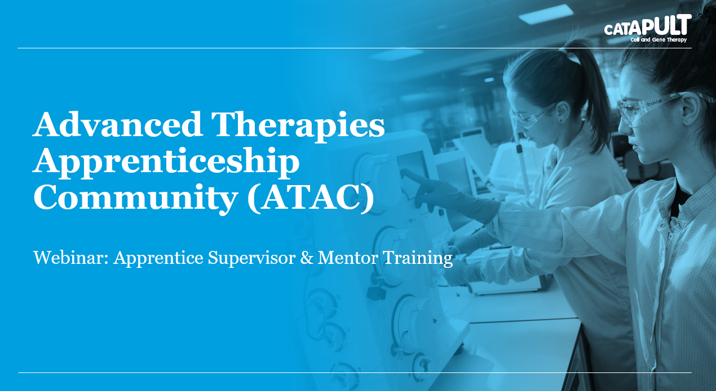

Apprenticeships have undergone significant reform and there is growing interest across the Advanced Therapies Community to secure a talent pipeline of technical skills to support ATMP research, commercialisation and scale-up to market. Specialist apprenticeships have been developed by employers to address these development needs. Supporting your apprentice within the business, either as a supervisor or mentor, is critical to the success of their apprenticeship. In this webinar you will learn a little of the background in to apprenticeship reform and the expectations on quality, typical content of new apprenticeship standards, end point assessment and the role of the apprentice, training provider, supervisor and mentor.

Target Audience: Supervisors and mentors new to supporting apprentices
Duration: 1 hr Webinar
Learning Outcomes:
- Typical content of new apprenticeship standards and expectations of quality
- Role of the employer in assessing competence and end point assessment
- Expectations of the apprentices supervisor and mentor within the business

